FULL TITLE OF THE MANUSCRIPT IN ALL CAPITAL LETTERS (CONCISE, NO ABBREVIATIONS, NO SUBTITLES)
[Author details omitted for blind peer review. Do NOT include names, affiliations, or any identifying information in this file.]
Abstract
Write your abstract here (150–250 words, no citations, no undefined abbreviations). Structure: Background: Briefly describe the poblem and motivation. Objective: State the aim of the study. Method: Describe the approach used. Results: Summarize the key findings with quantitative data where possible. Conclusion: State the main conclusion and its significance.
Keywords
keyword one, keyword two, keyword three, keyword four, keyword five (use 5–8 keywords; comma-separated; all lowercase; avoid repeating words from the title)
1. Introduction
Write the introduction here. Provide background, problem statement, and research objectives. Define all abbreviations at first use, for example: Artificial Intelligence (AI). Numbers one to nine are written as words; use numerals for 10 and above. Citation examples in this section: Single source — cite as [1]. Two sources — cite as [2, 3]. Multiple consecutive sources — cite as [4–6]. Place citation before the punctuation mark, for example: …as reported in previous studies[1]. This sentence demonstrates citing a range of sources [2–5]. When citing two non-consecutive sources, use a comma [1, 4]. Always number references in the order they first appear in the text.
2. Literature Review
Summarize and critically evaluate prior work related to your study. Identify the research gap. Multiple citations example: Several researchers have investigated sustainable materials for engineering applications [1, 2, 3]. Studies in the last decade show growing interest in bio-composite structures [3–6]. The compressive strength of recycled aggregates was found to be 15–20% lower than conventional concrete [7]. However, no study has simultaneously evaluated all three performance parameters under field conditions, which is the contribution of the present work.
3. Methodology
A. Materials
Describe all materials used. State the source, grade, and relevant properties. Example: Ordinary Portland Cement (OPC) conforming to IS 12269:2013 was used as the binder. Fine aggregate with a specific gravity of 2.65 and water absorption of 1.2% was procured from a local quarry [1].
B. Experimental Procedure
Describe the steps followed in sufficient detail for reproducibility. Use past tense throughout this section. Tests were conducted in accordance with ASTM C109 [2] for compressive strength and ASTM C1585 [3] for water absorption. Each test was repeated three times and the mean value is reported.
C. Data Analysis
Describe statistical or analytical tools used. Analysis of Variance (ANOVA) was performed using SPSS v26.0 [4]. Equation example — number all equations sequentially:
Compressive Strength = Load / Area … (1)
Water Absorption (%) = [(W_{s} − W_{d}) / W_{d}] × 100 … (2)
Equations are referenced in text as: Eq. (1) was used to compute compressive strength, while Eq. (2) gives water absorption. All quantities use SI units (kg, m, s, °C, MPa, etc.).
4. Results and Discussion
Present and interpret the key findings. Place each figure or table after its first mention in the text. Reference figures and tables by number, for example: The compressive strength values of all three samples are presented in Table 1. Sample C achieved the highest compressive strength of 45.1 MPa, exceeding the standard limit of 40.0 MPa, as shown in Figure 1. These results are consistent with findings reported in [1, 5]. Use past tense for describing results and present tense for interpretations and conclusions drawn from those results.
Table 1: Physical and mechanical properties of Samples A, B, and C. Values represent the mean of three trials. SI units are used throughout.
Parameter | Sample A | Sample B | Sample C | Standard Limit
Compressive Strength (MPa) | 42.3 | 38.7 | 45.1 | ≥ 40.0
Water Absorption (%) | 4.2 | 5.1 | 3.8 | ≤ 5.0
Density (kg/m³) | 2340 | 2280 | 2410 | 2200–2500
Flexural Strength (MPa) | 18.6 | 16.9 | 19.4 | ≥ 17.0
← Caption is placed ABOVE the table, centered, 8pt font. Use minimal borders (top and bottom lines only — NO vertical lines). Do not use colour fills in the final version.
As shown in Table 1, Sample C demonstrated the best overall performance, with compressive strength of 45.1 MPa and the lowest water absorption of 3.8%. The density of all samples fell within the acceptable range of 2200–2500 kg/m³ [2]. The superior performance of Sample C may be attributed to its lower water-to-cement ratio and denser microstructure, as reported by earlier studies [3, 6].
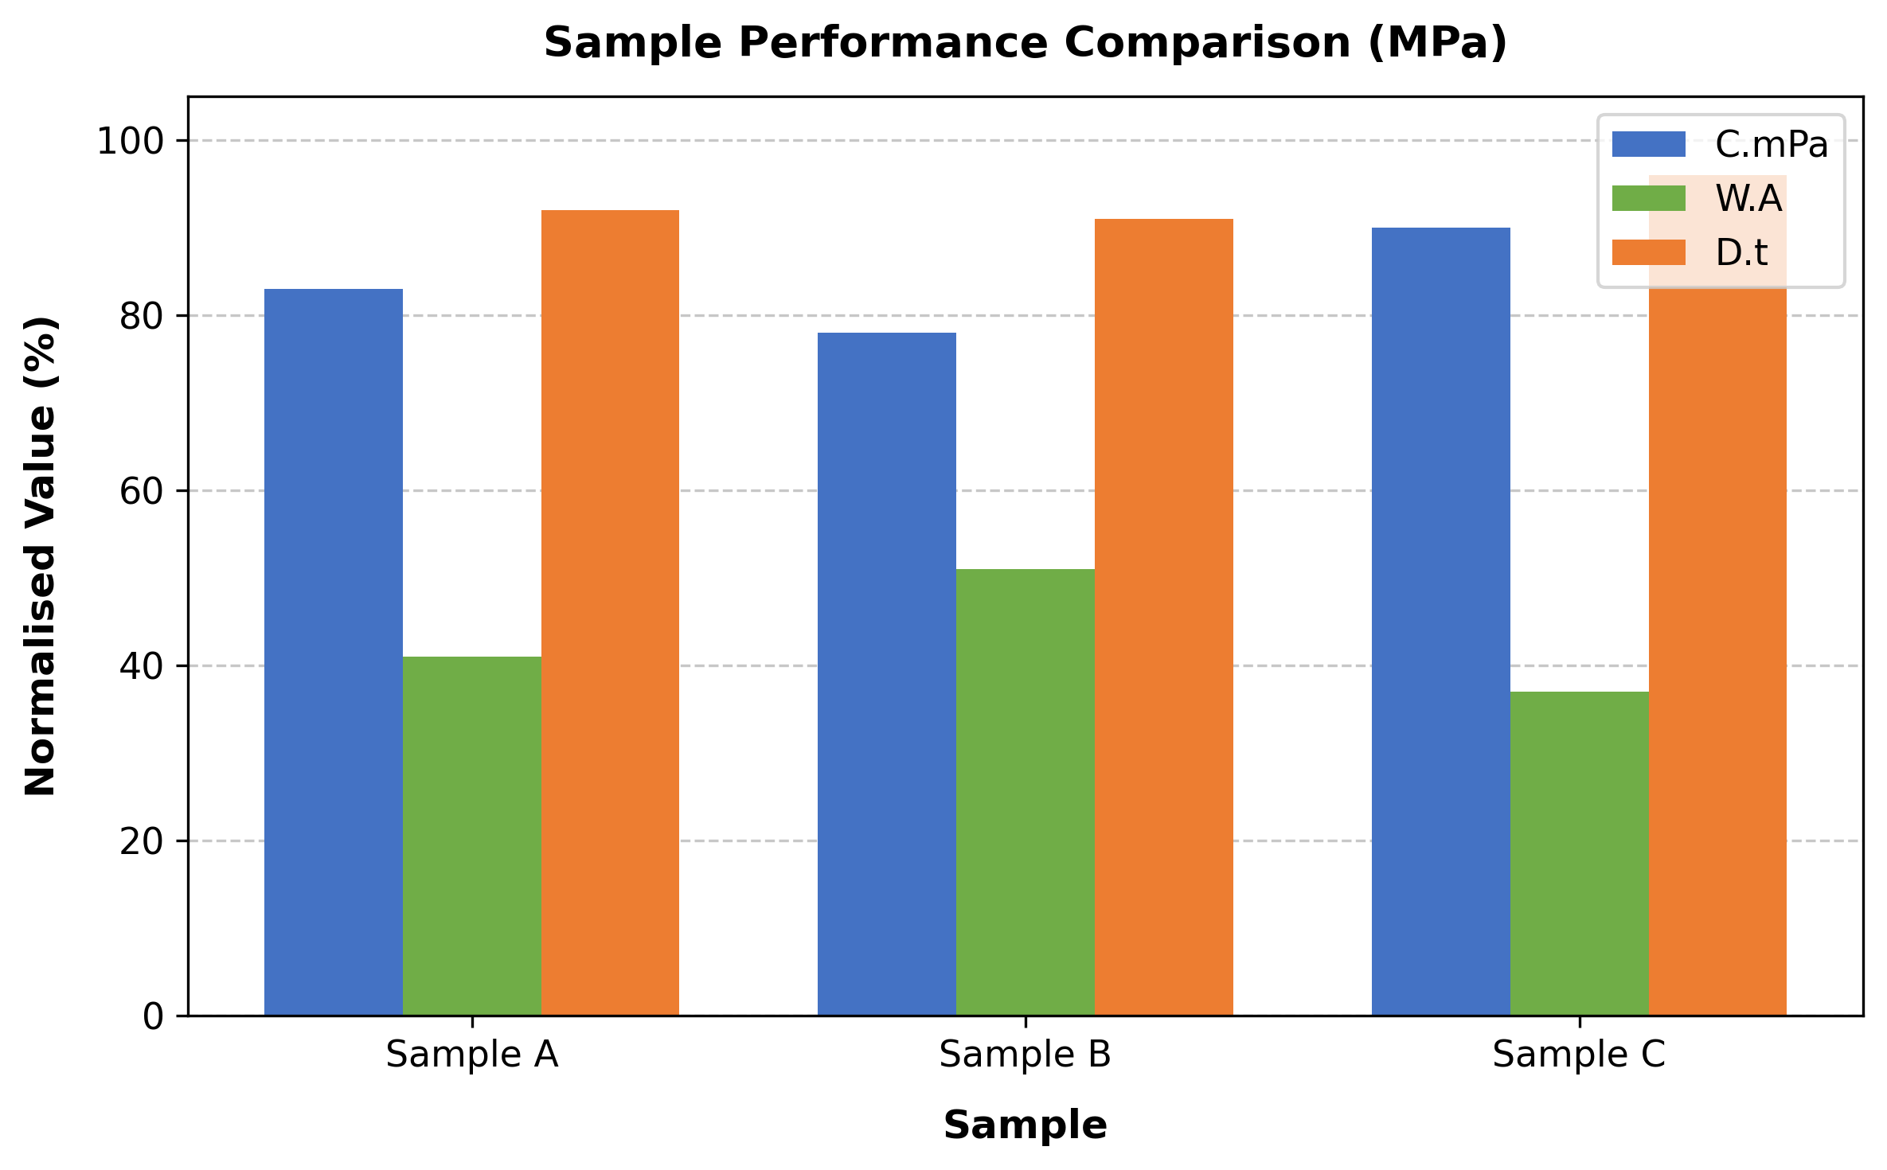
Figure 1: Normalised performance comparison of Samples A, B, and C across three parameters (Compressive Strength, Water Absorption, and Density) expressed as a percentage of the maximum observed value. Higher values indicate better performance for Compressive Strength and Density; lower values are preferred for Water Absorption.
← Caption is placed BELOW the figure, centered, 8pt font. Figures must be ≥ 300 DPI. Insert the figure after its first mention in the text.
The normalised comparison in Figure 1 confirms that Sample C consistently outperforms Samples A and B. This finding supports the hypothesis that optimized mix proportions yield superior mechanical and durability properties. Future studies should investigate long-term performance under field exposure conditions [7, 8].
5. Conclusion
Summarize the principal findings using present tense. Do not introduce new data. Avoid copying sentences verbatim from the Results section. Example: Sample C exhibits the highest compressive strength (45.1 MPa) and lowest water absorption (3.8%), making it the most suitable candidate for structural applications. The developed material meets all standard specifications and presents a viable eco-friendly alternative to conventional construction materials. Future work should include large-scale field trials, life-cycle cost analysis, and long-term durability assessment.
Acknowledgement
(Optional) Acknowledge funding agencies, laboratories, or individuals who supported the research. Do not mention author names or institutional affiliations here. Example: The authors gratefully acknowledge the financial support provided by [Funding Agency Name] under Grant No. XXXX.
Conflicts of Interest
The authors declare no conflict of interest.
References
References are listed in the order of first appearance in the text. Do NOT use author-year format (e.g., Smith, 2020). Do NOT use footnotes.
[1] Author A, Author B, Author C. Title of the journal article in sentence case. Journal Name, vol. X, no. Y, pp. ZZ-ZZ, Year.
Format: Authors. Title. Journal (italic), vol., no., pp., Year.
[2] Author D. Book Title in Title Case. Publisher Name, Year.
Format: Authors. Book Title (italic). Publisher, Year.
[3] Author E, Author F. Title of conference paper. In Proceedings of the Conference Full Name, City, Country, Year, pp. AA-BB.
Format: Authors. Title. In Proceedings (italic), Year, pp.
[4] Author G (or Organization Name). Title of the web page or report. Available: https://www.example.com/page (Accessed: DD Mon. YYYY).
Format: Author/Organization. Title. Available: URL (Accessed: date).
[5] Author(s). Title. Source details, Year.
[6] Author(s). Title. Source details, Year.
[7] Author(s). Title. Source details, Year.
[8] Author(s). Title. Source details, Year.

