RESEARCH ARTICLE
Title of the Manuscript in Title Case: Concise, Specific and Informative

First Author Name¹, Second Author Name^{2*}, Third Author Name¹
¹Department Name, Institution / University Name, City, State, Country
²Department Name, Institution / University Name, City, State, Country
*Corresponding Author: corresponding.author@institution.edu

ABSTRACT
Replace this text with an abstract of about 150–250 words written as a single paragraph. State the problem and why it matters, the objective of the study, the methods or approach used, the principal quantitative results and the main conclusion with its implication. The abstract must be self-contained: do not cite references, do not use undefined abbreviations and do not refer to tables, figures or equations. Report key numbers with their units, for example an accuracy of 93.4% or an error of 5.77 m/s². Avoid general statements that could apply to any paper; every sentence should say something specific about this work. This template reproduces the layout of articles published in the International Journal of Engineering, Science and Environment (IJESE); type over the example text and keep the styles.
Keywords: keyword one, keyword two, keyword three, keyword four, keyword five (five to eight keywords)

1. INTRODUCTION
This document is a dummy article that doubles as the IJESE author template. Type over the example text, or paste your own text using “Keep Text Only” and apply the matching style from the Styles gallery: Paper Body for text, Heading 1 to Heading 3 for headings, Caption for captions, Paper Figure for figures, Table Text inside tables, MTDisplayEquation for displayed equations and Reference for the reference list. Do not change the page size, margins, columns, fonts or the running header and footer.
The Introduction should establish the context of the work, summarise what is already known, identify the specific gap that the paper addresses, and end with a clear statement of the objectives and contributions. Cite references in the text with numbers in square brackets, numbered in the order in which they are first cited [1]. Use one bracket per source, for example [2], [3], and an en dash for a continuous range, for example [4]–[6]. A reference number may be used as a noun only with a word such as “in [7]” or “as reported in [8]”.
The main contributions of this work are the following. First, state the first contribution in one sentence. Second, state the second contribution. Third, state the third contribution. The remainder of the paper is organised as follows: Section 2 reviews related work, Section 3 describes the methodology, Section 4 presents the results and discussion, and Section 5 concludes the paper.

2. LITERATURE REVIEW
Review the most relevant and recent work critically rather than listing papers one by one. Group studies by approach or theme, compare their strengths and limitations, and show how the present work differs. Earlier studies addressed the problem with approach A [9]–[12], while later work introduced approach B [13]–[15]. Book-length treatments of the topic, which give useful background for new readers, are available in [16], [17].

2.1. Second-Level Heading
Second-level headings are numbered 2.1, 2.2 and so on and use the Heading 2 style (Arial Bold Italic 9 pt, blue). Use them to divide a main section into logical parts. The heading styles keep a heading with the paragraph that follows it.

2.1.1. Third-Level Heading
Third-level headings are numbered 2.1.1, 2.1.2 and so on and use the Heading 3 style (Arial Italic 9 pt). Avoid more than three levels of headings.

2.2. Research Gap
End the review with a short paragraph that states precisely what is missing in the existing literature and how this paper fills that gap. Recent preprints [18], theses [19], conference papers [20]–[22] and technical reports [23] may be cited, but prefer peer-reviewed sources where available, and make sure that every cited work appears in the reference list and every listed work is cited.

3. METHODOLOGY
Describe the data, materials, study area, experimental set-up, model or algorithm in enough detail that another researcher could reproduce the work. State the software, versions and hardware used, and give the source of every dataset [24] and software package [25]. Standards followed in measurement or testing should be cited [26], and quantities should be given in SI units [27].

3.1. Equations
Insert each equation with Word’s equation editor (Insert → Equation) or MathType in a paragraph of the MTDisplayEquation style, which centres the equation and places its number flush right after a tab. Number all displayed equations consecutively in parentheses and punctuate them as part of the sentence. For example, the model output is
$ŷ=σ\left(Wx+b\right)$ (1)
where W is the weight matrix, x is the input vector, b is the bias and σ(·) is the activation function. Define every symbol immediately after the equation in which it first appears. Model accuracy is assessed with the mean absolute error and the root-mean-square error:
$MAE=\frac{1}{N}\sum_{i=1}^{N}{\left|y_{i}−ŷ_{i}\right|}$ (2)
$RMSE=\sqrt{\frac{1}{N}\sum_{i=1}^{N}{{\left(y_{i}−ŷ_{i}\right)}^{2}}}$ (3)
and the coefficient of determination is
$R^{2}=1−\frac{\sum_{i=1}^{N}{{\left(y_{i}−ŷ_{i}\right)}^{2}}}{\sum_{i=1}^{N}{{\left(y_{i}−ȳ\right)}^{2}}}$ (4)
where N is the number of samples, y_{i} and ŷ_{i} are the observed and predicted values, and ȳ is the mean of the observed values. Refer to equations in the text as Eq. (2), or as Eqs. (2) and (3). Variables are italic, vectors and matrices may be bold, and units, abbreviations and function names such as sin, log and exp are upright.

3.2. Tables
Tables are numbered with Arabic numerals in the order in which they are cited, and every table must be cited in the text before it appears, as in Table 1. The caption is placed above the table in the Caption style, in bold, in the form “Table 1: Caption text”. Use the Table Text style inside the table, with a dark header row with white bold text, and give units in the column headings. Keep tables within one column wherever possible, and build them with Word’s table tool rather than pasting images.
Table 1: Formatting of the main elements of an IJESE article
Element | Style and format
Page | A4, margins 2.54 cm top/bottom, 2.0 cm left/right; two columns
Title | Paper Title: Arial Bold 16 pt, dark blue, centred
Authors | Paper Authors: Arial Bold 9 pt, centred
Affiliations | Paper Affiliation: Times New Roman Italic 9 pt
Abstract | Abstract Text: Times New Roman 8.5 pt, shaded box
Body text | Paper Body: Times New Roman 9 pt, justified
Heading 1 | Arial Bold 9.5 pt, capitals, dark blue, rule below
Heading 2 | Arial Bold Italic 9 pt, blue
Captions | Caption: 8 pt, centred; tables above, figures below
References | Reference: 7.5 pt, IEEE style, numbered automatically

4. RESULTS AND DISCUSSION
Present the results in a logical order, using tables and figures to support the text rather than repeat it. Report the uncertainty of every measured or estimated quantity and the statistical test used to compare methods, and compare your results numerically with the best previously reported result [2]. Table 2 compares the proposed model with three baseline models; the proposed model achieves the highest accuracy and the lowest RMSE of all the methods compared on the same test data.

4.1. Figures
Figures are numbered with Arabic numerals in the order in which they are cited and are referred to in the text as Fig. 1, or Figs. 1 and 2. Insert each figure “In Line with Text” in a paragraph of the Paper Figure style and place the caption below it in the Caption style, in the form “Fig. 1. Caption text.” Size figures to the column width.
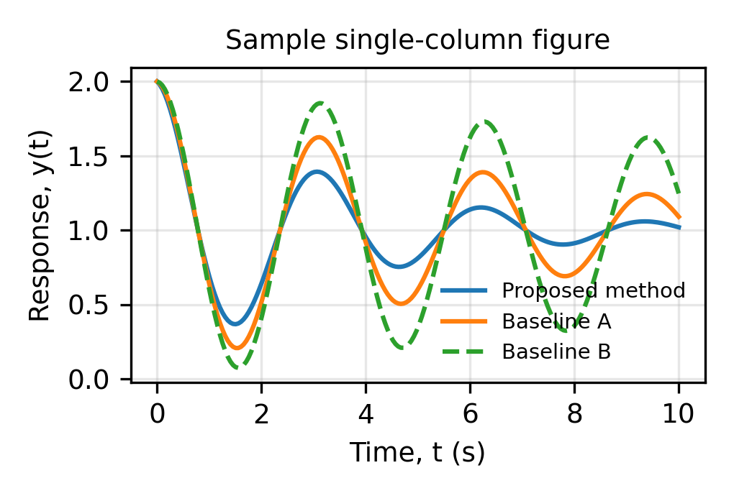
Fig. 1. Example of a single-column figure: response of the proposed method compared with two baselines.
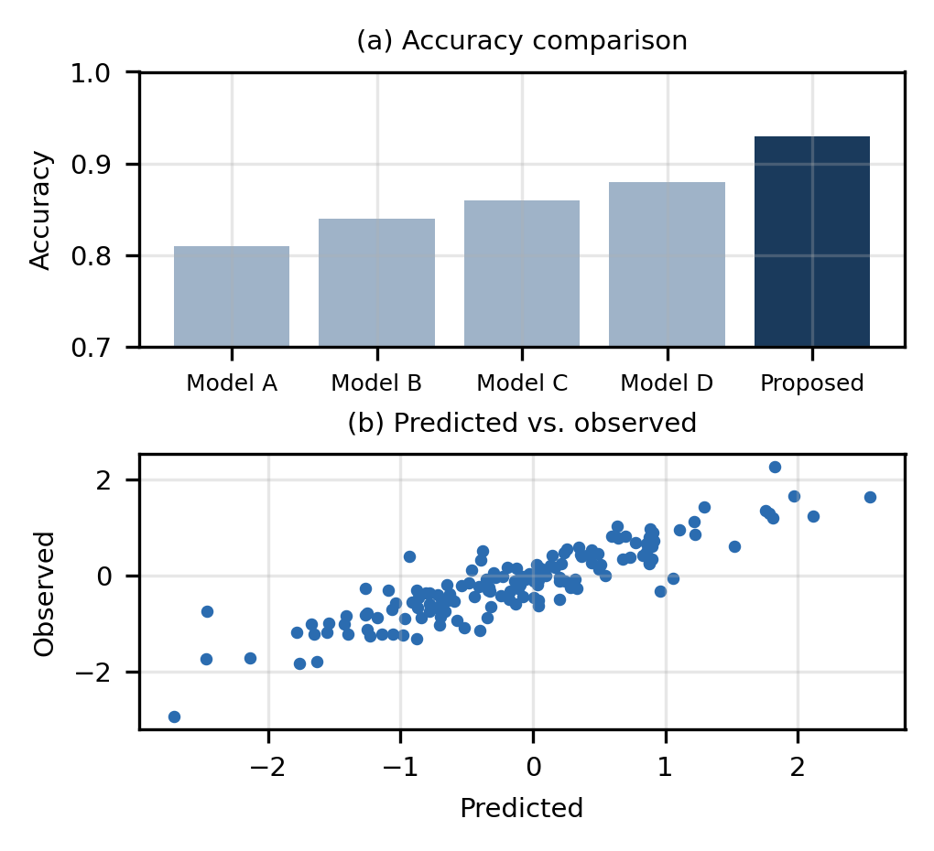
Fig. 2. Example of a figure with two panels: (a) accuracy of the compared models and (b) predicted versus observed values.
Submit figures at a resolution of at least 300 dpi, with axis labels, units and legends that can be read at the printed size. Use sub-figure labels (a), (b) and describe each panel in the caption, as in Fig. 2. Choose colours that remain distinguishable in greyscale, and combine colour with line styles or markers. Use the same colour for the same method in every figure, keep fonts inside figures consistent with the text, and avoid titles inside the plot area because the caption already describes the figure. Photographs and micrographs need a scale bar, and maps need a north arrow, a scale and a statement of the data source. When a figure is reproduced or adapted from another publication, obtain permission from the copyright holder and cite the source in the caption.
Table 2: Performance of the compared models on the test set (mean ± standard deviation)
Model | Accuracy (%) | F1-score (%) | RMSE (units)
Baseline A [1] | 81.2 ± 1.4 | 80.1 ± 1.3 | 0.412
Baseline B [3] | 84.6 ± 1.1 | 83.9 ± 1.2 | 0.366
Baseline C [6] | 86.3 ± 0.9 | 85.9 ± 0.9 | 0.341
Proposed model | 93.4 ± 0.6 | 92.9 ± 0.6 | 0.218

4.2. Discussion
Interpret the results, explain why they occur, compare them quantitatively with previous studies [28]–[30], and discuss the practical implications. Fig. 2(a) shows that the proposed model gives the highest accuracy, and Fig. 2(b) shows close agreement between predicted and observed values.

5. CONCLUSION
Summarise the main findings and contributions with the key quantitative results, without repeating the abstract word for word. State the practical significance of the work, its main limitations and specific directions for future research. Do not cite references, figures or tables in the conclusion.

DECLARATIONS

Acknowledgement
Acknowledge people, institutions or facilities that helped with the work but do not qualify as authors. Remove this heading if there is nothing to acknowledge.

Author Contribution
A. First Author: conceptualisation, methodology, software, writing – original draft. B. Second Author: supervision, validation, writing – review and editing. C. Third Author: data curation, formal analysis. For a single author, state that the author is solely responsible for the work.

Data Availability Statement
State where the data supporting the findings can be found (repository name and DOI or URL), or that the data are available from the corresponding author on reasonable request, or that no new data were created.

Conflict of Interest
The authors declare that there are no conflicts of interest. If any competing interest exists, describe it here.

Funding
This research received no specific grant from any funding agency in the public, commercial or not-for-profit sectors. If the work was funded, give the name of each funder and the grant number.

REFERENCES
- A. B. Author, C. D. Author, and E. F. Author, “Title of the journal article in sentence case,” Journal Name, vol. 12, no. 3, pp. 145–160, 2024, doi: 10.xxxx/xxxxxxx.
- A. B. Author and C. D. Author, “Title of an article that uses article numbers instead of pages,” Journal Name, vol. 15, Art. no. 108809, 2025, doi: 10.xxxx/xxxxxxx.
- A. B. Author, C. D. Author, E. F. Author, and G. H. Author, “Title of the conference paper,” in Proc. Int. Conf. Name (Abbrev.), City, Country, 2023, pp. 1–6, doi: 10.xxxx/xxxxxxx.
- A. B. Author, C. D. Author, E. F. Author, G. H. Author, I. J. Author, and K. L. Author, “Title (up to six authors: list all),” Journal Name, vol. 9, no. 1, pp. 1–14, 2023.
- A. B. Author et al., “Title (seven or more authors),” Journal Name, vol. 21, no. 4, pp. 512–530, 2024.
- A. B. Author and C. D. Author, “Title of an early-access article,” Journal Name, early access, 2026.
- A. B. Author, “Title of the article,” Journal Name, vol. 7, no. 2, pp. 88–97, Apr.–Jun. 2025.
- A. B. Author, “Title of the magazine or newspaper article,” Magazine Name, vol. 8, no. 2, pp. 20–25, Mar. 2024.
- A. B. Author and C. D. Author, “Title of the journal article,” Journal Name, vol. 33, pp. 1021–1035, 2021, doi: 10.xxxx/xxxxxxx.
- A. B. Author, C. D. Author, and E. F. Author, “Title of the conference paper,” in Proc. IEEE Int. Conf. Name, City, Country, 2022, pp. 245–250, doi: 10.xxxx/xxxxxxx.
- A. B. Author, “Title of the journal article,” Journal Name, vol. 18, no. 6, pp. 3310–3322, 2022, doi: 10.xxxx/xxxxxxx.
- A. B. Author and C. D. Author, “Title of an accepted article,” Journal Name, to be published, doi: 10.xxxx/xxxxxxx.
- A. B. Author, C. D. Author, and E. F. Author, “Title of the journal article,” Journal Name, vol. 40, no. 2, Art. no. e0123456, 2025, doi: 10.xxxx/xxxxxxx.
- A. B. Author and C. D. Author, “Title of a paper in online-only proceedings,” in Proc. Conf. Name, virtual, 2021, pp. 77–84, doi: 10.xxxx/xxxxxxx.
- A. B. Author, “Title of the journal article,” Journal Name, vol. 11, no. 9, pp. 901–915, 2024, doi: 10.xxxx/xxxxxxx.
- A. B. Author, Title of the Book, 2nd ed. City, Country: Publisher, 2020.
- A. B. Author, “Title of the chapter,” in Title of the Edited Book, C. D. Editor, Ed. City, Country: Publisher, 2021, pp. 45–67.
- A. B. Author and C. D. Author, “Title of the preprint,” arXiv preprint arXiv:2405.12345, 2024.
- A. B. Author, “Title of the thesis,” Ph.D. dissertation, Dept. of Name, University Name, City, Country, 2022.
- A. B. Author and C. D. Author, “Title of the conference paper,” in Proc. Nat. Conf. Name, City, India, 2024, pp. 112–118.
- A. B. Author, “Title of the M.Tech. thesis,” M.Tech. thesis, Dept. of Name, Institute Name, City, India, 2023.
- A. B. Author, “Title of the presentation,” presented at the Conference Name, City, Country, Month DD–DD, YYYY.
- Organisation Name, “Title of the technical report,” City, Country, Tech. Rep. XX-123, 2023. [Online]. Available: https://www.example.org/report
- A. B. Author, “Title of the dataset,” Repository Name, Version 2, 2024, doi: 10.xxxx/xxxxxxx.
- A. B. Author, “Name of the software or code,” Version 1.0, 2025. [Online]. Available: https://github.com/user/repository
- Title of the Standard, Standard number (e.g., IEEE Std 1234-2020, ISO 12345:2021 or IS 456:2000), 2020.
- Organisation Name, Title of the Guide or Handbook, 9th ed. City, Country: Organisation Name, 2019.
- A. B. Author, C. D. Author, and E. F. Author, “Title of the journal article,” Journal Name, vol. 14, no. 5, pp. 700–712, 2023, doi: 10.xxxx/xxxxxxx.
- Government Department Name, “Title of the government report,” Ministry Name, Government of Country, City, Country, 2024.
- Organisation Name, “Title of the web page,” Website Name. Accessed: Jan. 15, 2026. [Online]. Available: https://www.example.com/page

